I-Sadukey Indicator for MT4 – Free Download

I-Sadukey Indicator for MT4 Download – Free – [Trading Finder]

Meta: Download of the I-Sadukey Indicator MT4 – Visualizes trend direction and forecasts potential market movements – Identifies optimal trade entry points
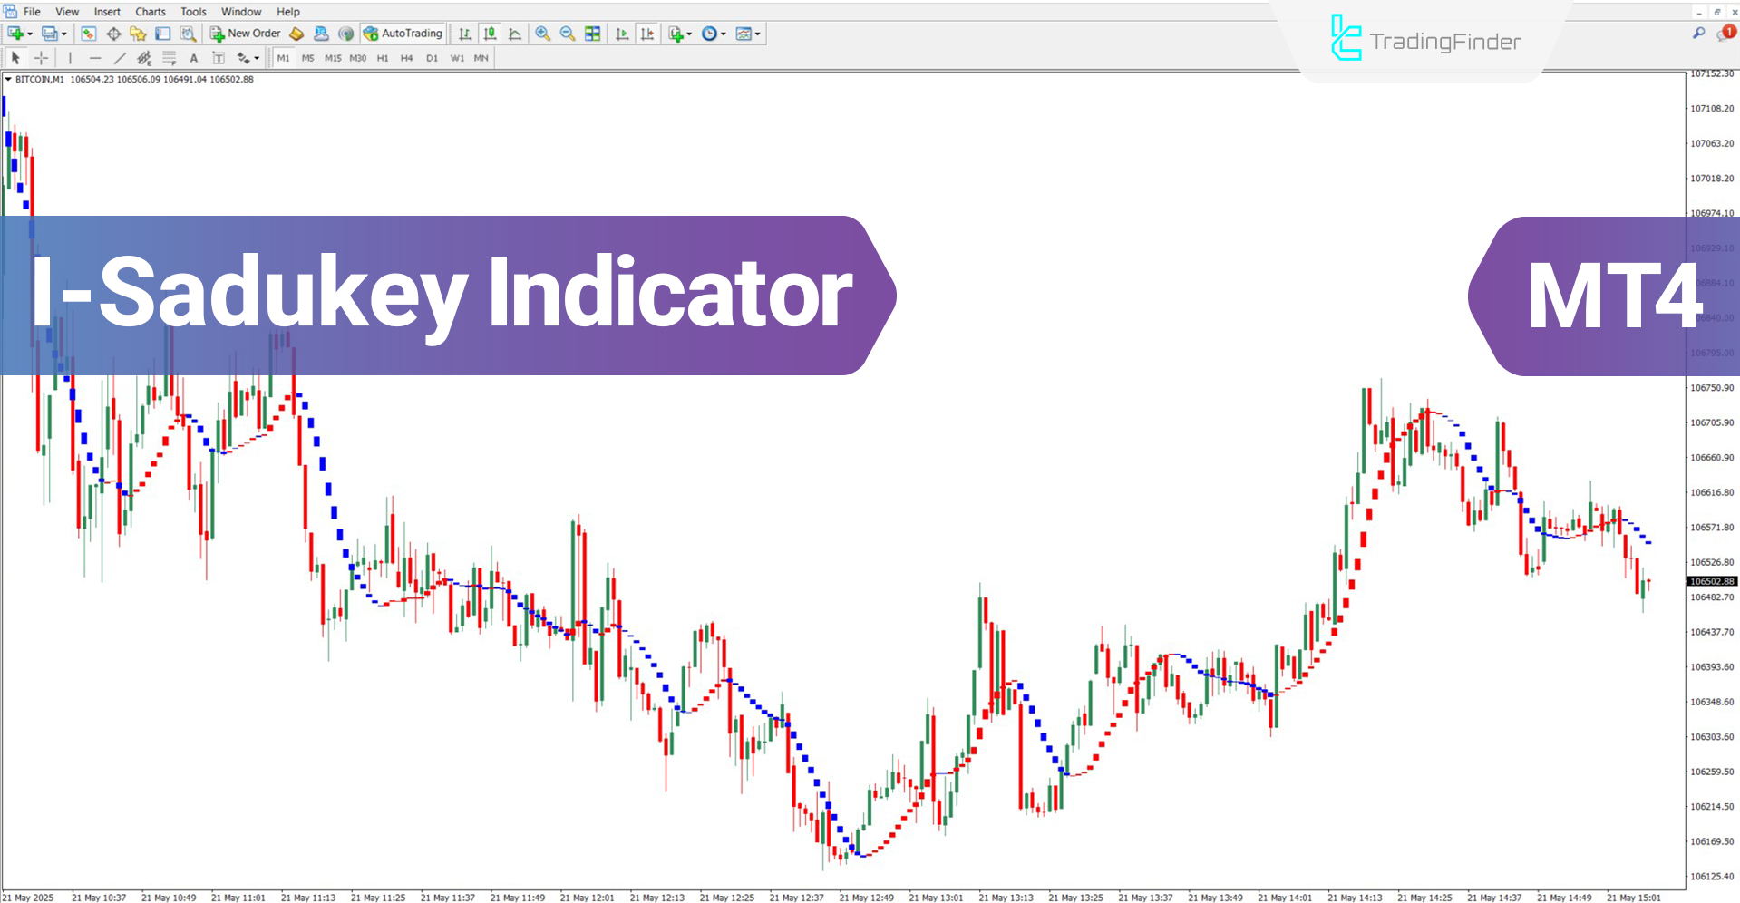
Alt: I-Sadukey Indicator
Caption: Introduction and free download of the I-Sadukey Indicator

The I-Sadukey Indicator is designed to detect trend strength and direction within the MetaTrader 4 platform. This trading tool uses color coded histograms of varying sizes to reflect the current market condition.
It is one of the most powerful tools in technical analysis and can be applied across various markets, including cryptocurrency, forex, stocks, and commodities.

I-Sadukey Indicator Specifications Table
The following table shows the specifications of the indicator:
Category | Trading Tool – Signal & Prediction – Currency Strength
Platform | MetaTrader 4
Skill Level | Beginner
Indicator Type | Reversal – following
Timeframe | Multi timeframe
Trading Style | Scalping – Day Trading – Swing Trading
Market | All markets

I-Sadukey Indicator at a Glance
This indicator visualizes the trend direction and optimal entry points for buy and sell positions using histogram color changes. Red bars indicate an uptrend, while blue bars reflect a downtrend. The height of the histogram bars shows the strength of the trend.

Uptrend
Based on the USD/CAD currency pair in the 1-hour timeframe, the I-Sadukey indicator signals a shift from downtrend to uptrend by changing the histogram color. In this case, the color change from blue to red marks a suitable entry point for buy positions.
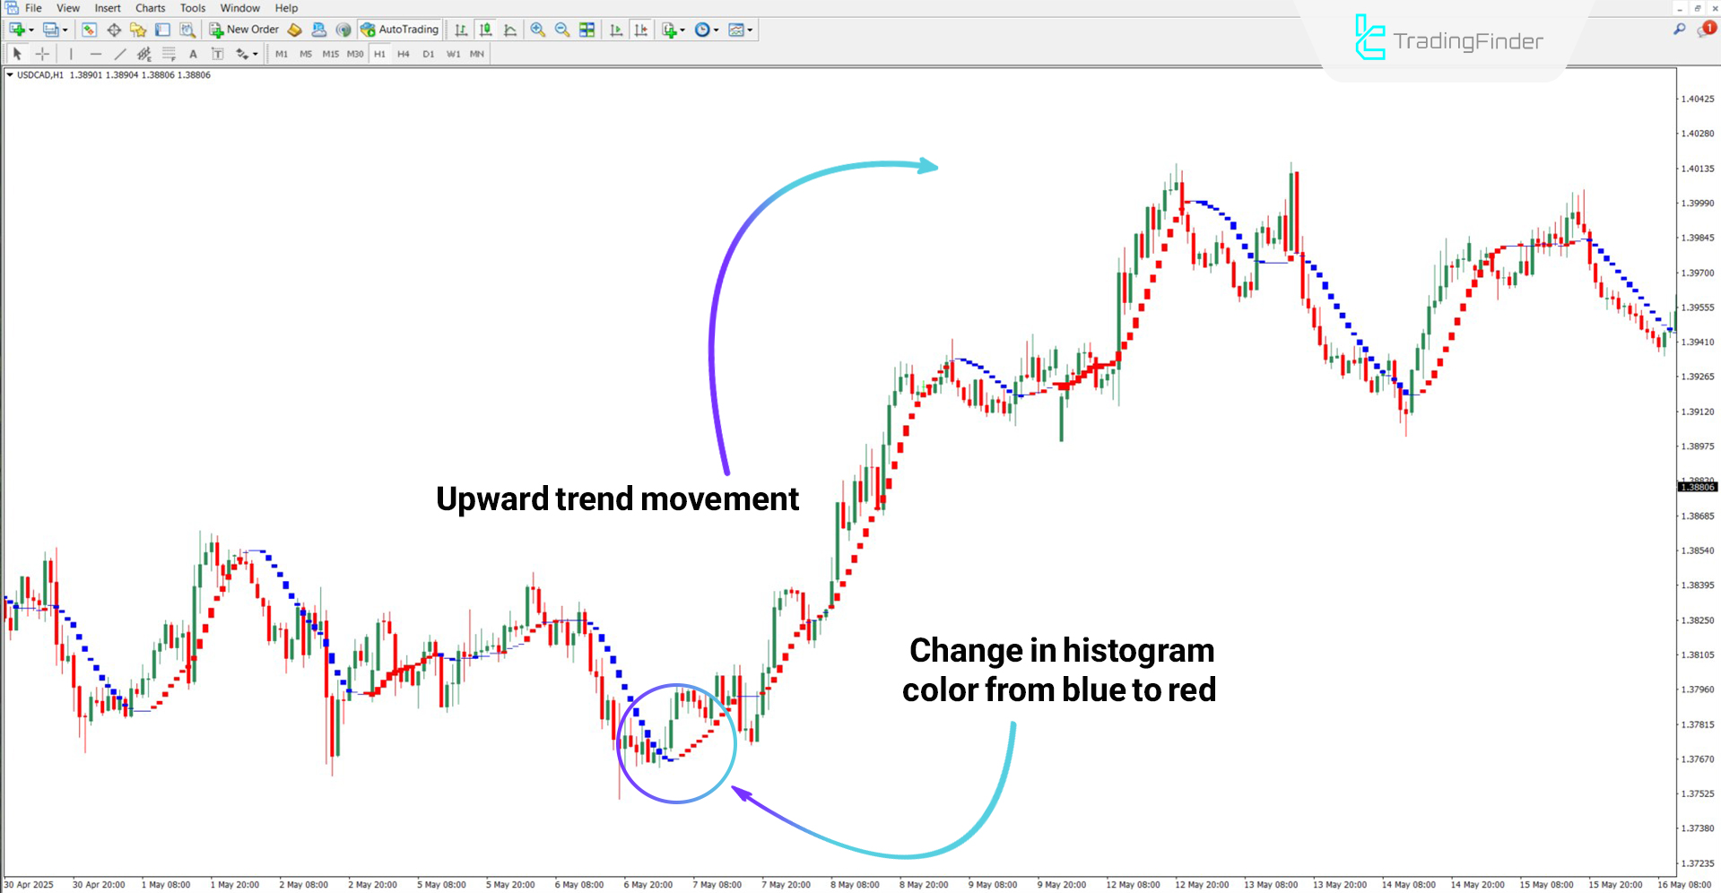
Alt: Uptrend analysis using I-Sadukey histograms
Caption: Identifying trend direction with the I-Sadukey Indicator

Downtrend
According to the Polkadot cryptocurrency chart on the 30-minute timeframe, a color change from red to blue in the histogram indicates the beginning of a downtrend. Traders may consider this color transition as an entry point for sell positions.
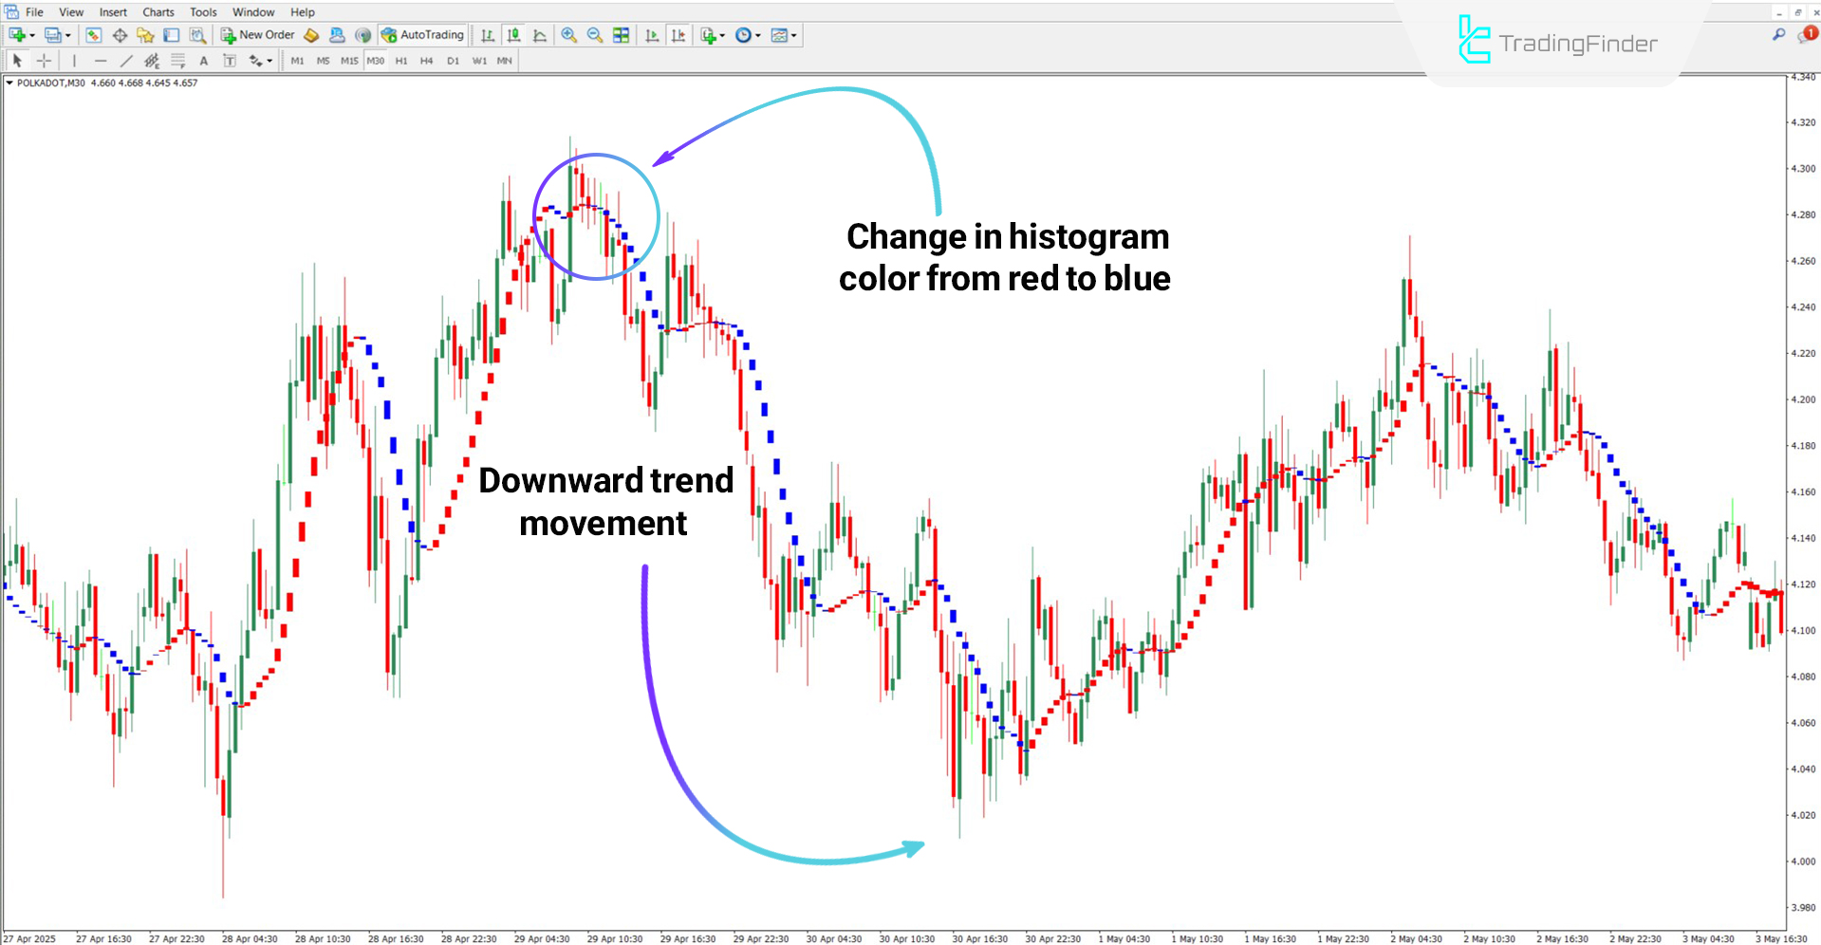
Alt: Detecting trend reversal using the I-Sadukey Indicator
Caption: Downtrend analysis using the I-Sadukey Indicator

Conclusion
The I-Sadukey Indicator, by displaying bars with different colors and heights, facilitates the detection of trend direction and identifies suitable buy or sell opportunities.
Red histograms indicate an uptrend, while blue bars signal a downtrend. It is worth noting that this trading tool requires no manual input, as it automatically analyzes data across multiple charts.

FAQ
What is the I-Sadukey Indicator?
A tool used to detect the direction and strength of market trends.
What do the blue bars represent?
Blue bars indicate a downtrend in market price.

